Types of Mobile Money Settlement
# Source: AI Source: Provided by: [Data Path: Persons Table -> ID Column: 1, Name_En Column: Motasem Essam] -> From: [ChatGPT] on [1/21/2026]
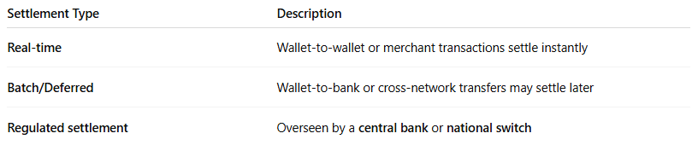

Settlement Type | Description
Real-time | Wallet-to-wallet or merchant transactions settle instantly
Batch/Deferred | Wallet-to-bank or cross-network transfers may settle later
Regulated settlement | Overseen by a central bank or national switch

